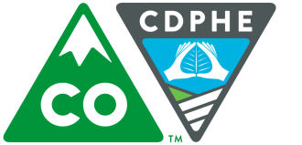 | DISPOSAL NOTIFICATION FORM  CalWood/Left Hand Canyon Wildfires, October 2020

Building Owner | Owner’s Name:
 | Street:
 | City: |  | State: | Zip Code:
Telephone #
( )
Site Address | Owner’s Name:
 | Street:
 | City: | County: |  | Zip Code:
Disposal Contractor | Company/Contractor’s Name:
 | Street:
 | City: |  | State: | Zip Code:
Telephone #
( )
Landfill | Landfill Name:
 | Street:
 | City: |  | State: | Zip Code:
Telephone #
( )

Submit form by mail/email (no fee is required) to:

Indoor Environment Program Permit Coordinator
Colorado Dept. of Public Health and Environment
APCD-IE-B1
4300 Cherry Creek Drive South
Denver, CO 80246-1530
cdphe.asbestos@state.co.us

Please call 303-692-3100 with any questions

