After the Fire
First, I have no expertise in insurance. I am merely a homeowner who lost our house in a wildfire as you did. I am, however, a physicist who loves to simplify things. So, I hope this is helpful.
Our Home
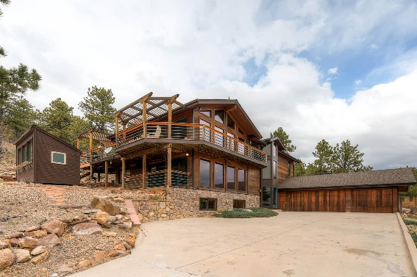
In 2001, we sold our split-level in south Boulder and moved to Foothills Ranch Drive, a seven-home gated community about five miles north of city limits. This 5,500 square foot house was our dream. When we moved in, fire was not a concern. That changed as drought worsened. For example, the house had a cedar shake roof which we quickly replaced with a Class A asphalt roof.. As our concern grew, we hired a fire consultant and worked with Lefthand Fire Department to reduce trees and grass from our lot. They showed us a photo of our house in the station and said, “We will fight for your house.”
The First Fire
In about 2005, a lightning strike hit a log that later set the hill behind us on fire. Lefthand brought a pumper truck to our house (ready to cover it with foam if needed). The wind was a gentle downslope and slurry bombers subdued the fire.
The Calwood Fire
Over the ensuing years we worked closely with Lefthand and earned “Firewise” status. We also worked with them to emplace a large firebreak up the hill behind us. At about 1:30 on Saturday, October 17, 2020, we received phone call and e-mail urging us to immediately evacuate. I walked out and saw black smoke coming down the hill at about 40 knots and said to my wife, “Let’s go.” We grabbed cellphones and laptops and went to the Marriott. From our room we watched the fire move down the hill with an enormous cloud of smoke. At about 4 PM, our Tesla Powerwalls went off-line indicating that the system was compromised. Later that night we saw a drone video of our house engulfed in flames. I quickly made a reservation for the Residence Inn.
Contacting Insurance
Sunday morning I called our insurance company, Amica, and was told that an adjuster would call on Monday. We went to COSTCO and bought clothes, toiletries, and food. We had nothing. I should tell you a bit about Amica. We bought our insurance from Amica years ago because they are excellent in handling claims (including a top rating from JD Powers). It a Mutual Company meaning that we are owners, voting on the directors and receiving a dividend at the end of the year. Having said that, I think that you can have a really good experience with any of the usual companies. State commissions oversee the policies and I think all Colorado policies are quite similar.
Our “Adjuster”
Gina, our adjuster, called us the next day, then every day for a week making sure that we were OK. She went over the terms of our policy and I was barely listening. She asked where were staying and said they would take care of the bill. On Tuesday, she said they had sent $150 K to our checking and engaged HomeLink to find us a place to stay. A week later we moved to a house in Arvada with Court providing “Red Carpet” treatment for furniture and household goods.
Actions and Mindset
At this point of relative stability, I suggest that you review the macro-terms of your policy. It is, IMHO, a very simple and straightforward statement of what you are entitled to. Moreover, I think that your mindset is really important going forward. Here’s what worked for us. We wanted everything that were entitled to under the terms and nothing more. Our burned-out neighbors seem to find the insurance much more difficult, in part because (I suspect) they are asking for compensation beyond the policy’s intent, e.g., emotional distress over grandmother’s rocking chair, or hyper-expensive items they should have had “riders” for. Moreover, we perceived our adjusters as our friend and agent. We had three, Gina, another for the car, and Brett for reconstruction. Each wanted to maximize our payments (it’s not their money). The main hurdle was convincing management above them. We learned that if we provided them adequate supporting data, they would find a way to get us paid.
Coverage A
“Coverage A” is the first order of business because other items are tied to it. Our was about $750 K, far below the replacement cost as I suspect for you too. Our policy had a 30% overage up to the rebuild cost. Brad came from Amica, met us at the site and we discussed the house. Also, we tried to sell it for $950 K about 4 years earlier and the sale fell through at the last moment, hence our insurance level. Our realtor had photos that were also useful. With rebuild costs of $400/ft² it was obvious that it would take more than $2 M to rebuild this house. Our Coverage A payment was thus fixed and we received payment in December, only delayed for Brett to complete the needed rebuild calculations. There was nothing to negotiate or argue about here. And, they did not care what we did with the money.
The Demolition
Next, the demolition. We are, as I understand it, required to restore the land to its natural state, including removing the foundation and septic tank within two years. I wanted to do it quickly because flying material (steel doors) could injure someone, and we intended to sell the lot. A company was marketing this service and proposed a cost of about $60 K. As this coverage was also raised by the same 30% we had enough insurance money to pay for it. Brett wanted to review the proposal to make sure that it was OK. In the meantime, Jessica Logue, a small business owner (Denver Demolition) contacted me and, after a site visit, bid in the low 30’s for the job. A company with webinars promoted by the County advised that if you got a lower bid, keep the information from your insurer and keep the money. That is not who we are. I told them of the lower bid, they paid me, Jessica did the work and I paid her.
Personal Property Insurance
Now, the “sticky” part, the personal property insurance. Again, our objective was to provide the best possible information. This had a limit of more than $500 K, a lot of money. I decided to organize the information in a spreadsheet. (I think they may have had forms, which I ignored.) I organized it into sections by room. I had columns for description, cost, source of the cost estimate (e.g. memory, web), condition, depreciation (minimal in most cases as just my wife and I in the house), claim amount, and comments. These were the main categories of items and how I handled them:
- Major purchases, e.g. furniture usually purchased in Boulder, estimates from memory;
- Amazon purchases – easy to get data;
- Closets – I broadly described the contents, e.g., six medium quality suits, slacks and coats; a tux from when I worked in DC and an estimated value;
- Kitchen utensils – estimates by drawers with examples, e.g. Japanese knives; and
- Art and kimonos from Japan (expensive items) – So, how to value these? I thought about the Antiques Roadshow, “And, that’s what the piece would bring at auction.” I went to the web and found their Japanese appraiser in New York. We described each item and how we acquired it. Some were purchased and some inherited. She wrote a letter with her valuations.
We had absolutely no evidence for most of the items in the claim. Nonetheless, they paid us the full amount of the claim. Note: If we had to sell these things because we moved to a smaller place or some other reason, I don’t think that we would have received more than a few cents on a dollar.
Other Items
The other items, landscaping, and out-buildings (we had a greenhouse) were tied to the Coverage A and they paid them full. Nothing to discuss here. Two things that you might want to verify in your policy. The rent is to be covered “until suitable permanent accommodations” or up to two years. They were OK as long as our rent properties are not better than our lost home. (This was easy.) Note, if you rebuild, they will pay an additional 10% of Coverage A (about $100 K extra) for costs related to changes in the building code. This is also easy money – our house was built 30 years ago. Building codes now meet international standards for efficiency, fire turnarounds and sprinklers, and the like.
Rebuilding
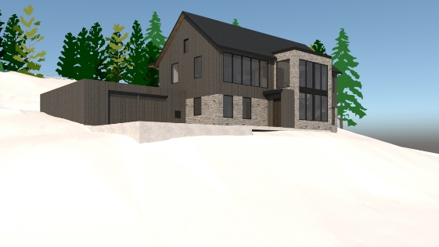
So why are we rebuilding? First, the properties on the market are generally low quality and unsuited to a couple growing older. We own the lot (we were offered $425 K for it, even burned) and love the location. With the increased Coverage A and the Personal Property money we can build a truly extraordinary house with a construction quality, energy efficiency, security, and accommodations for growing older (wheelchair access throughout and an elevator) unlike anything for sale. And, this house will be able to withstand any future fire (or flood). (I am writing a paper on fire-resistant houses.)
Summary
So, here is my summary advice:
- Interact with your insurance company directly. You will have the sympathy effect working for you;
- Treat your adjuster like your friend and agent in the company, assuming that they want to help you and then they likely will;
- Don’t ask people for things that they cannot give you. This will just frustrate you both; and
- Bring full honesty and candor to every conversation.
COVID
Frankly, COVID has been a much bigger issue than the fire. My business was international teambuilding in Asia, Europe and Russia and it’s gone. My wife and I were “1-K” (one-hundred-thousand-mile fliers) on United nearly every recent year. Since December 2019 (for my birthday party in Berlin) we have not traveled more than one hour away in the car.
Coping Emotionally
Most say that my Junko and I coped better than most with the fire, and perhaps that’s the case. I have spent the past 25 or so years working with teams and leaders. I found that Addressing Unfortunate Realities with 100% Commitment to what you most want is a powerful creativity process. So, what are the Unfortunate Realities in play?
- Our 30-year-old house was increasingly unsuited to our future needs:
  - Three levels, curving stairs, and narrow doorways that were increasingly difficult to navigate as we aged;
  - The wood intensive house was deteriorating and increasingly difficult to maintain in a COVID environment;
  - It was not robust against climate change (damaged in the 2013 flood and burned to the ground) and difficult to retrofit; and
  - Not resilient to future resource shortages, e.g. fossil fuels.
- What about the “stuff” we lost?
  - Lots of items spanning many years;
  - We were unable to dispose it of even though much was in “deep storage” in a locations (basement and garage) and generally ignored;
  - We attempted to move some years ago and all this stuff was a real burden; and,
  - In the end, it’s just stuff.
- So, what are we 100% Committed to:
  - Living in gratitude for “what matters most,” our health, our love and caring for each other, and having the emotional and financial resources to come out of this better;
  - We have a wonderful house under construction, paid for with insurance money, which meets all our requirements in ways that our old house never could. We expect to move in later this year.
About Climate Change (I wrote a paper about this.)
- Greenhouse gases, primarily water vapor and carbon dioxide are stable gases so earth will continue heating irrespective of anything that we do;
- For example, reducing emissions will only reduce the rate of increase in the heating, not the heating;
- Drought, floods, fires, and storms will become more extreme as we cross “tipping points” like an ice-free arctic.
Follow-on
If you would like to discuss anything further, e-mail me at charliepellerin@gmail.com and we can do a Zoom. I have time for you. And, I hope this was helpful.

