Healthy Eating

Sample Child Care Policy
The following sample child care policy is designed to provide support for programs, staff and family handbooks. Policy can make your practices known, understood and supported by staff, families and older children. When you develop policy statements for your handbooks and orientation materials, your preferred practices are more likely to be permanent, even with changes in your center or staff.
-----------------------------------------------------------------------------------------------------------------------
We at (name of program) support your child’s healthy food choices by:
- Gently encouraging children to try fruits and vegetables and giving positive reinforcement when they do.
- Role-modeling positive behaviors by eating fruits and vegetables in the presence of children.
- Observing and supporting hunger and fullness cues.
- Providing opportunities for nutrition education for parents and staff.
- During celebrations and holiday parties, our program will offer fruits and vegetables and other healthy foods.
- Not using food as a reward.
Providing good nutrition for your child is a partnership. We at (name of your program) ask for your support:
- For packed lunches, please include fruits and/or vegetables.
- For celebrations and holiday parties, please provide healthy foods (especially fruits and vegetables). An approved list of age-appropriate foods will be provided.
We at (name of program) understand the importance of providing age appropriate food and beverages and because of this:
- If a mother wishes to breast feed exclusively, the program will make every effort to provide breast milk to the child and supplement only when breast milk is gone.
- We will continue supporting families who are breastfeeding beyond 12 months.
- We will follow the American Academy of Pediatrics recommendations and not serve any food or drink other than breast milk and/or iron fortified infant formula in a bottle unless medically necessary.
- We will only serve whole milk for children younger than 2 years old and fat-free or 1% milk for children aged 2 years and older.
- Water will be clearly visible and available to the children at all times (indoors and outdoors).
We at (name of your program) are committed to our children’s health and nutrition. We recognize the importance of the staff as positive role models for the children as they learn to live healthy lives. Therefore:
- Staff will not drink soda and sugary beverages in front of the children in their care.
- During functions or meetings at the center, we will only permit water, milk or 100% fruit juice to be served.

Child Care Nutrition and Physical Activity Policies

NUTRITION:
Fruits and Vegetables
- We offer fruit to children at least 2 times a day.
- We only offer fruit canned in its own juice (no syrups), fresh or frozen.
- We offer vegetables to children at least 2 times a day.
- We only offer vegetables steamed, boiled, roasted or lightly stir-fried with little added fat.
Meats and Grains
- We offer fried or pre-fried (frozen and breaded) meats (chicken nuggets) or fish (fish sticks) once a week or less.
- We offer fried or pre-fried potatoes (French fries, tater tots, hash browns) once a week or less.
- We offer high fat meats like sausage, bacon, hot dogs or bologna once a week or less.
- We offer beans or lean meats at least once a day.
- We offer high fiber, whole grain foods at least 2x a day.
- We offer sweets or salty foods less than once a week or never.
Beverages
- We make drinking water freely available so children can serve themselves both inside and outdoors.
- We rarely offer sweetened drinks other than 100% juice.
- We serve only 1% or skim milk to children age 2 or older.
- We do not have soda or other vending machines on site.
Menus and Variety
- We have 3 week (or greater) cycle menu that allows for seasonal changes.
- Our menus include healthy items from a variety of cultures.
- Our menus include a combination of new and familiar foods.

Feeding Practices
- Our staff help children determine if they are full before removing their plate.
- Our staff help children determine if they are still hungry before serving additional food.
- Our staff gently and positively encourages children to try a new or less favorite food.
- We do not use food to encourage positive behavior.
Foods offered Outside of Regular Meals and Snacks
- We provide and enforce written guidelines for healthier food brought in and served for holidays and celebrations (see below).
- We celebrate holidays with mostly healthy foods or non-food treats.
- Our fundraising efforts consist of selling non-food items only.
Supporting Healthy Eating
- Our staff joins children at the table for meal times.
- We always serve meals family style.
- Our staff always consumes the same food and drink as the children.
- WE provide visible support for good nutrition in 2 to 5 year old classrooms and common areas through use of posters, pictures and displayed books.
- Our staff often talks informally with the children about trying and enjoying healthy foods.
Nutrition Education for Staff, Children and Parents
- We provide training opportunities for staff on nutrition (other than food safety and food program guidelines) 2X per year or more.
- We provide teacher-directed nutrition education to the children, through a standardized curriculum, 1x per week or more.
- We provide nutrition education to parents 2x per year or more.

Healthy Guidelines for Celebrations
Please help us encourage lifelong healthy habits among our children. We encourage parents to join us for the child’s birthday or other special occasion and bring food to help celebrate. Please select or prepare healthier food options that your child enjoys. Suggestions include:
- Favorite fruits
- Lower fat baked goods (ex. Mini muffins with icing)
- Favorite dishes that aren’t necessarily desserts
- Foods with special family or cultural significance
- Healthy foods in fun shapes

Also, consider celebrating with favorite stories, music, games or activities. Often the most important thing to your child is that you took the time to help plan something special. Please talk with the Director if you have questions or need ideas. We know that it’s hard to break old habits like cake, ice cream and candy, but let’s give it a try!

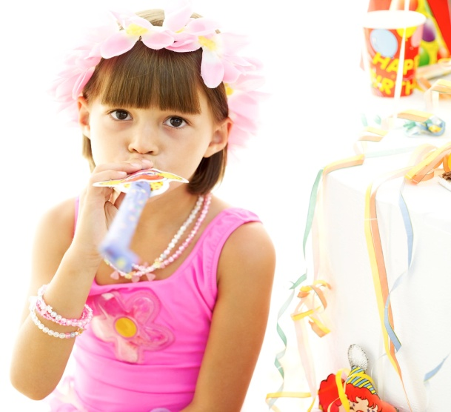

Physical Activity
Active Play and Interactive Time
- We provide at least 120 minutes of active play time to all children each day.
- We provide opportunities for outdoor play 2 or more times per day.
- We ensure that children are rarely seated for periods of more than 30 minutes.
- We do not withhold active play time for children who misbehave. Instead, we provide additional active play time for good behavior.
- We rarely show television and videos.
Play Environment
- We provide fixed play equipment (tunnels, climbing and balancing equipment) that is extensive and varied for all children.
- We provide portable play equipment (wheeled toys, balls, hoops, ribbons) that is diverse and available for children to use at the same time.
- We make outdoor portable play equipment freely available to all children all of the time.
- Outdoor play space includes an open, grassy area and a track/path for wheeled toys.
- Indoor play space is available for all activities, including running, when weather does not permit outdoor play.
Supporting Physical Activity
- Our staff often encourages children to be active and often joins children in active play.
- We provide visible support for physical activity in 2 to 5 year old classrooms and common areas through use of posters, pictures and displayed books.
Physical Activity Education
- We provide training opportunities for staff on physical activity (other than playground safety) 2x per year or more.
- We provide teacher-directed physical activity education for children, through a standardized curriculum, 1x per week or more.
- We offer physical activity education to parents 2x per year or more.

