

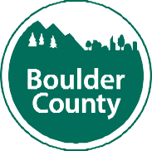**Community Services Department**

Sundquist Building • 3482 N. Broadway • Boulder, Colorado 80304 • Tel: 303.441.3560 • Fax: 303.441.4550

**Mailing Address:** P.O. Box 471 • Boulder, Colorado 80306 • [**www.bouldercountycommunityservices.org**](http://www.bouldercountycommunityservices.org/)

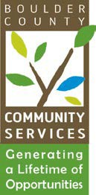DATE: July 10, 2024

TO: Community Actions Program Administering Board FROM: Kathryn Lehman, PERL Coordinator

RE: August 20, 2024 - CAP Administrative Board Meeting

The next meeting of the Community Actions Program Administering Board will be held in the Nino Gallo Conference Room in the Community Services Building, 3482 Broadway St, Boulder, CO as well as virtually via Microsoft TEAMS on Tuesday, August 20, 2024, at 5:30 p.m. If you are not a sitting member of the board and would like to attend this meeting, please reach out to Kathryn Lehman at [klehman@bouldercounty.gov](mailto:klehman@bouldercounty.gov) for a TEAMS invite.

**AGENDA**

1. Call to Order
2. Public Comment (5 min.)
3. Approval of Board Minutes (2 min.)
4. CAP program updates (5 min.)
5. Review and Voting on Approval of Applications for new Board Members (25 min.)
6. Presentation from Claudia Ibarra-Arellano about the Cultural Brokers Program launching its first Public Training (15 min.)
7. Discussion

**Claire Levy** *County Commissioner* **Marta Loachamin County** *Commissioner*



**Ashley Stolzman County** *Commissioner*