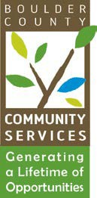DATE: September 4, 2024

TO: Community Actions Program Administering Board

FROM: Kathryn Lehman, PERL Coordinator

RE: September 10, 2024 - CAP Administrative Board Meeting

The next meeting of the Community Actions Program Administering Board will be held in the Nino Gallo Conference Room in the Community Services Building, 3482 Broadway St, Boulder, CO on Tuesday, August 10, 2024, at 5:30 p.m. If you are not a sitting member of the board and would like to attend this meeting, please reach out to Kathryn Lehman at [klehman@bouldercounty.gov](mailto:klehman@bouldercounty.gov) for a TEAMS invite.

**AGENDA**

1. Call to Order
2. Public Comment (2 min.)
3. Approval of Board Minutes (2 min.)
4. Onboarding and informal meet and greet with newly appointed board members (5 min.)