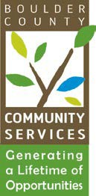DATE: February 11, 2025

TO: Community Actions Program Administering Board

FROM: Kathryn Lehman, PERL Coordinator

RE: February 18, 2025 - CAP Administrative Board Meeting

**AGENDA**

1. Call to Order 5:30 p.m.
2. Public Comment 5:30 p.m. to 5:35 p.m.
3. Approval of Board Minutes 5:35 p.m. to 5:40 p.m.
4. CAP program updates and upcoming events 5:40 p.m. to 5:50 p.m.
   * Next PERL Boards and Commissions Training Feb 25-March 6
5. Election of Board officers 5:50 p.m. to 6:30 p.m.
6. Discussion 6:30 p.m. to 7:00 p.m.
   * Volunteer to make and post a bio template?