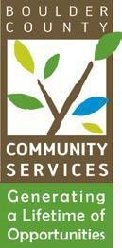
DATE: April 1, 2025
TO: Community Actions Program Administering Board
FROM: Kathryn Lehman, PERL Coordinator
RE: April 15, 2025 - CAP Administrative Board Meeting

AGENDA

- Call to Order 5:30 p.m.

- Public Comment 5:30 p.m. to 5:35 p.m.

- Approval of Board Minutes 5:35 p.m. to 5:40 p.m.

- CAP program updates and upcoming events 6:00 p.m. to 6:20 p.m.

- Discussion 6:20 p.m. to 6:30 p.m.

