DATE: May 1, 2025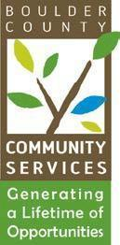

TO: Community Actions Program Administering Board

FROM: Kathryn Lehman, PERL Coordinator

RE: May 20, 2025 - CAP Administrative Board Meeting

**AGENDA**

1. Call to Order 5:30 p.m.
2. Public Comment 5:30 p.m. to 5:35 p.m.
3. Approval of Board Minutes 5:35 p.m. to 5:40 p.m.
4. CAP program updates and upcoming events 5:40 p.m. to 6:00 p.m.
5. Discussion 6:00 p.m. to 6:10 p.m.
6. Close Meeting 6:10 p.m.
7. Demo empathy board game for those that can stay 6:10 p.m. to 7:10 p.m.