DATE: June 1, 2025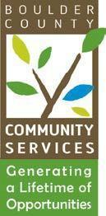

TO: Community Actions Program Administering Board

FROM: Kathryn Lehman, PERL Coordinator

RE: June 18, 2025 - CAP Administrative Board Meeting

**AGENDA**

1. Call to Order 5:30 p.m.
2. Public Comment 5:30 p.m. to 5:35 p.m.
3. Approval of Board Minutes 5:35 p.m. to 5:40 p.m.
4. CAP program updates and upcoming events 5:40 p.m. to 6:00 p.m.
   * PERL Boards and Commissions training took place May 31, 8 new graduates
   * Cultural Brokers Cultural Collective - June 12, Training on Intellectual and Developmental Disabilities, Sister Carmen Community Center
   * Colorado Community Action Conference, July 16-18, Loveland, CO
   * Cultural Brokers Meet and Greet, July 23, Thorne Nature Center, Lafeyette
     + CAP Board is invited, asked to bring a dish to help support CB and Claudia
   * PERL and Cultural Brokers Field Trip July 30
     + opportunity to play Empathy Boardgame
5. Discussion 6:00 p.m. to 6:30 p.m.